**NAME:** SAHIL KADU

**PROJECT:** STARTUP FUNDING CASE STUDY PART 2

**ANSWER1:**

* First open the file using pandas data frame.
* Then we dropped the rows with which have “CityLocation” column as NaN.
* Some cells have two cities, we separated it using split operator.
* Checked & corrected spelling mistakes.
* Converted “AmountinUSD” column to integer.
* Then we added “AmountinUSD” values separately as per “CityLocation” and sorted them in descending order.
* We calculated percentage to determine the “CityLocation” with maximum funding.
* We plotted a bar graph of city on X axis & %funding on Y axis.
* We found that city **“Bangalore”** has max funding with over 49.7% & hence it is ideal choice for location.

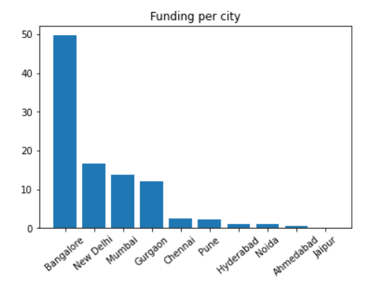

**ANSWER2:**

* First open the file using pandas data frame.
* Then we dropped the rows with which have “InvestorsName” column as NaN.
* We created a dictionary function which will split every investor name & calculate its occurrence.
* We passed “InvestorsName” column through the function. This will create a dictionary.
* We sort it in descending order.
* We created pandas dataframe using this dictionary.
* As a result, we are able to find out those top 5 investors who have invested max number of times – **“Sequioa Capital”, “Accel Partners”, “Kalaari Capital”, “SAIF Partners”, “Indian Angel Network”.**

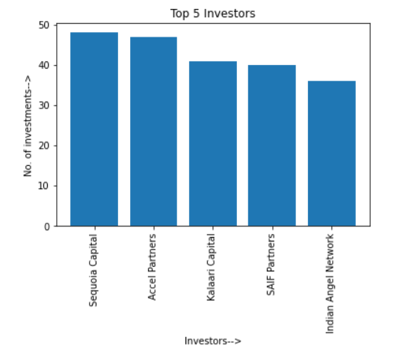

**ANSWER3:**

* First open the file using csvDictReader.
* Initialize an empty dictionary
* Correct all spelling mistakes in “StartupName” column.
* Split each cell of “InvestorsName” column on the basis of “,” & then strip it which will remove spaces from both ends.
* Ignore all null spaces in “StartupName” & undisclosed investors in “InvestorsName”.
* Initialize dictionary with key as “InvestorsName” & value as set containing unique “StartupName”.
* For each key in dictionary replace the values with the length of the sets.
* Sort the dictionary in descending order.
* Create a pandas dataframe & print top 5 elements.
* Plot a bar graph with investors name on X-axis & number ofinvestments on Y-axis.
* As a result, we are able to get the top 5 investors in distinct companies – **“Sequioa Capital”, “Accel Partners”, “Kalaari Capital”, “Indian Angel Network”, “Blume Ventures”.**

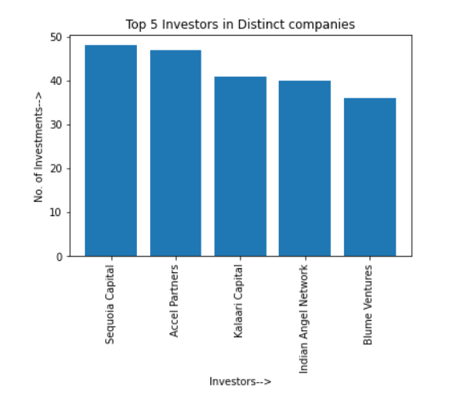

**ANSWER4:**

* First open the file using csvDictReader.
* Initialize an empty dictionary
* Correct all spelling mistakes in “StartupName” column & “InvestmentType” column.
* Split each cell of “InvestorsName” column on the basis of “,” & then strip it which will remove spaces from both ends.
* Ignore all null spaces in “StartupName” & undisclosed investors in “InvestorsName” & only include data which have “InvestmentType” as “Seed Funding” or “Crowd Funding”.
* Initialize dictionary with key as “InvestorsName” & value as set containing unique “StartupName”.
* For each key in dictionary replace the values with the length of the sets.
* Sort the dictionary in descending order.
* Create a pandas dataframe & print top 5 elements.
* Plot a bar graph with investors name on X-axis & number of companies on Y-axis.
* As a result, we are able to get the top 5 investors in distinct companies – **“Indian Angel Network”, “Rajan Anandan” , “LetsVenture”, “Anupam Mittal”, “Kunal Shah”.**

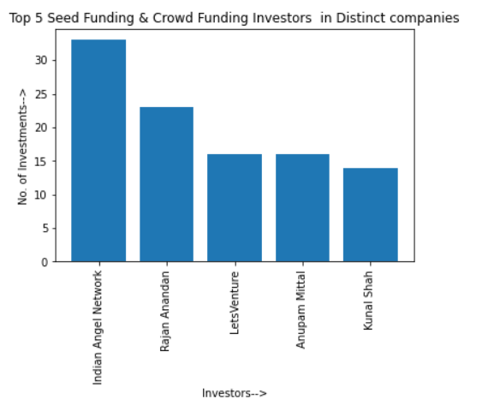

**ANSWER5:**

* First open the file using csvDictReader.
* Initialize an empty dictionary
* Correct all spelling mistakes in “StartupName” column & “InvestmentType” column.
* Split each cell of “InvestorsName” column on the basis of “,” & then strip it which will remove spaces from both ends.
* Ignore all null spaces in “StartupName” & undisclosed investors in “InvestorsName” & only include data which have “InvestmentType” as “Private Equity”.
* Initialize dictionary with key as “InvestorsName” & value as set containing unique “StartupName”.
* For each key in dictionary replace the values with the length of the sets.
* Sort the dictionary in descending order.
* Create a pandas dataframe & print top 5 elements.
* Plot a bar graph with investors name on X-axis & number of companies on Y-axis.
* As a result, we are able to get the top 5 investors in distinct companies – **“Sequoia Capital”, “Accel Partners”, “Kalaari Capital”, “Blume Ventures”, “SAIF Partners”.**

